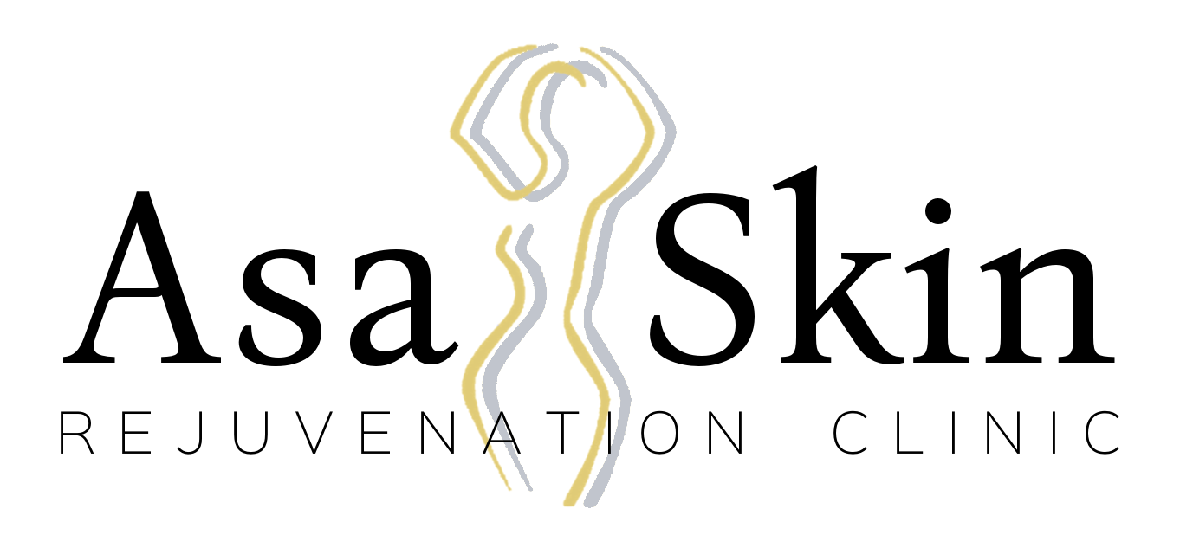

PATIENT INFORMATION

Date Patient Name

Address, City, State, Zip

Home Phone Cell Phone Work Phone

Email Address:

Birth Date Age Place of Employment

Please Circle One: Married / Single Please Circle One: Female / Male

May we leave detailed messages for you?: Cell Phone / Email / Both

Reason for Visit Referred By

Emergency Contact Name, Relationship, and Phone Number

Please explain any of the following that may apply:

Heart Condition Keloids

Diabetes Cold Sores/Herpes

Permanent Tattoos

Do you smoke? Yes No

Do you exercise? Yes No
Have you been on Accutane in the past 6 months? Yes No
Are you using Retin A, Glycolic, or Lactic Acid? Yes No

Please list any other medications that may make you photo sensitive:

Please list all medication you are currently taking (blood thinners, antibiotics, herbs, supplements, vitamins, aspirin, etc.):

Please list any facial/skin products and brands that you are currently using:

Please list all allergies:

Do you currently have or have ever had any of the following:
Kidney disease Yes No
Hepatitis Yes No
Severe depression Yes No
Needle phobia Yes No
Skin disease Yes No
Bleeding disorder Yes No
Recent stroke Yes No
Fainting/Dizzy spells Yes No

If you answered yes to any of the above, please explain:

Do you currently experience or have ever experience any of the following:
Breakouts Yes No
If yes, what frequency? Rarely, Sometimes, Often
Cystic breakouts Yes No
Scarring as a result of acne Yes No
Blackheads Yes No
Clogged pores Yes No
Hard bumps under the skin Yes No
Excessive oiliness Yes No
Dry patches Yes No

Skin History:
Have you had prolonged sun exposure, either outside or in a tanning bed, in the last three days? Yes No
If yes, are you currently sunburned? Yes No
Do you use tanning beds? Yes No
Do you use chemical tanning products? Yes No
Do you use sunblock on a regular basis? Yes No

When your skin is exposed to the sun for approximately one hour with no protection, how do you typically respond? Please circle one.
- Always burns, never tans
- Usually burns, tans with difficulty
- Sometimes burns mildly, gradually tans
- Rarely burns, tans with ease
- Very rarely burns, tans very easily
- Never burns, tans very easily
What is your ethnicity? Please circle one.
Caucasian Mediterranean Other______________________
Asian African American
Hispanic Native American
Female Patients:
Do you have permanent makeup? Yes No
Are you pregnant? Yes No
Are you breastfeeding? Yes No
Do you take oral contraceptives? Yes No
Do you take hormone medication? Yes No
Do you have excessive hair on your face and/or breasts? Yes No
Have you ever had facial hair removed? Yes No

Method of facial hair removal Date of last facial hair removal treatment

Date of last menstrual period

Have you ever had any service(s) similar to the ones we offer? If yes, please list date of last treatment and explain:

Is there anything else about you or your medical history that has not been addressed or explained? The more information we have about you, the better we can address your specific skincare questions and concerns.

*I certify that the above information and medical history is complete and accurate.*

X
Signature of Patient or Person Authorized to Sign for Patient

X
Printed Name of Patient or Person Authorized to Sign for Patient

X
Date

